About Us
The conception of Social Impact Assessment (Audit) has gained credence all over the world. Social Accounting, Impact Assessment and Audits facilitate organisations to evolve and strategies policies and practices that promote social capital and build harmonious cognations between business and other segments of society. Venerating stakeholders beyond shareholders, contributing to the economic, gregarious and environmental development of the communities in which it operates, conscientious stewardship, reverencing human dignity, etc. are a few principles organisations need to acclimate.
Social accounting and impact assessment (audit) sanctions a convivially responsible business to build on its subsisting monitoring, documentation and reporting systems to develop a process whereby it can account plenarily for its gregarious, environmental and economic impacts, report on its performance and draw up an action plan to ameliorate on that performance. Through the social accounting and audit process it can understand its impact on the circumventing community and on its beneficiaries and build accountability by engaging with its key stakeholders. In this way it can prove its value and amend its performance.
The idea of social audit (impact assessment) has gained credence all over the world. Social Accounting and Impact Assessment (Audit) helps organisations to evolve and strategies policies and practices that promote social capital and build harmonious relations between business and other segments of society. Respecting stakeholders beyond shareholders, contributing to the economic, social and environmental development of the communities in which it operates, conscientious stewardship, respecting human dignity, etc. are a few principles organisations need to adapt.
KSVAMRIT Social Asia is a pan India ‘Social Audit Firm (SAF)’ with focus on extending quality and world class services to ‘Social Enterprises (SE)’ and ESG for ‘Profit Enterprises’. With onset of SSE (Social Stock Exchange) at BSE and NSE; Initiation of the concept of ‘For Profit Social Enterprises (FPSE); Introduction of ‘Zero Coupon Zero Principal (ZCZP) Instruments’; Registration and/or listing possibilities of Non-Profit Organization (NPO)’ at SSE has suddenly brought Social Enterprises into forefront. On the other side, SEBI’s mandate for BRSR coupled with BRSR Core comprising 9 ESG attributes; BRSR Core for Value Chain (vendors side as well distribution channel side); Emergence of Assurance Providers on BRSR has put onus on Top listed companies for essential disclosures. In India, BRSR has gained two tractions – one mandatory for top 1000 listed companies and second BRSR Core becoming recommendatory for vendors and distribution channels if they wish to continue to be supplier or distributor to the blue chip companies.
We, at KSVAMRIT Social Asia, is a team of Practicing Professional, each one carrying extensive experience of serving the “Development Sector”. Besides Social Audit, the twin focus is on (i) complex compliance issues; social outreach; development of various reports – Project Concept Note (PCN), Project Report, Social Impact Assessment (SIA) Reports, other highly technical reports; CSR Compliances by Corporates as well as by Social Enterprises; Takeover and Acquisitions of SE; Promoting best practices through training, need assessment /baseline study, impact assessment, midterm and concurrent evaluations. We serve both private and public sector social projects; and (ii) Year round data collection for BRSR Reports; Awareness session for BRSR compliances; Developing master plan for BRSR Core; Developing master plan and its execution for ‘value chain’ (inclusive of Source 2 and Source 3); Developing assurance modalities and company specific validation tools.
KSVAMRIT Social Asia also have combination of young and budding professionals to handhold for (i) preparation of CSR Annual Reports, SE Annual Reports, Annual Impact Report, Various Registrations including registration with Ministries, Elections, and so on. (ii) handle BRSR related solutions and processes.
Rest assured, all the founder partners of ‘KSVAMRIT Social Asia’ are qualified Social Auditors and ‘SRO Empanelled Social Auditors (SESA)’.

Vision of KSVAMRIT Social Asia:
‘Passionate about Work Quality’
Mission of KSVAMRIT Social Asia::
‘World Class Working’.
Values of KSVAMRIT Social Asia are as follows: -
a) Highest Ethical Standards;
b) Treat each Partner and Associate with respect;
c) Be Methodical and Responsible;
d) Always Ready to learn new things;
e) Timely Delivery;
f) Unbending integrity in everything we do;
g) Disseminate Knowledge;
h) Smart Working;
i) Money is By-Product.

OUR TEAM

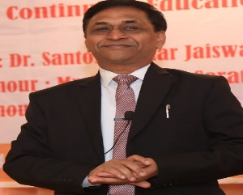 | 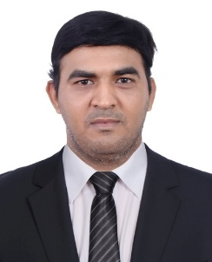 |  |  | 
Dr. Ajay Garg  Delhi - NCR | K Sriram Tamil Nadu | Pardeep Kumar  Hisar | Shravan Vishnoi Lucknow | Raj Kumar Arora  New Delhi
 |  |  | 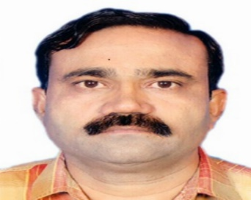 | 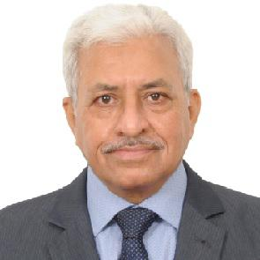
Rajeswara Rao Karnataka | TR Ravichandran  Chennai | Tanu Tyagi  Delhi - NCR | Ashok Sonje  Mumbai | Mohinder P Kharbanda  Gurgram

Feel free to contact the office near to your place or write back to us at socialauditorksvamrit@gmail.com
====================

